Vehicle Dynamics Analysis through Visualization for Nonlinear Control System tuning

Thesis

Presented in Partial Fulfillment of the Requirements for the Degree Master of Science in the Graduate School of The Ohio State University

By

Brian Joseph Lesko

Graduate Program in Mechanical Engineering

The Ohio State University

2023

Thesis Committee

Levent, Guvenc

Committee Member

Committee Member

Committee Member

Copyrighted by

Brian Joseph Lesko

2023

# Abstract

This paper dives into longitudinal vehicle dynamics using simulated data. The paper aims to emphasize the importance of data representation, using visually appealing methods to aid in understanding system behavior. Consequently, the behavior of an accelerating, or braking vehicle, can be more easily manipulated. Concisely, the paper consists of the following chapters: model selection, simulation setting, data collection, data filtering, model approximation, and fit evaluation. With result visualization at each step, a major goal in this paper is concise and accurate writing. The motivation of this paper began with the positional control of a real-world vehicle for autonomous stopping at red lights. The following sections will go over each step of the research while answering the following questions. One

# Vita

**BRIAN JOSEPH LESKO**

[brianjosephlesko@gmail.com](mailto:brianjosephlesko@gmail.com)|[www.github.com/BrianLesko](http://www.github.com/BrianLesko) |linkedin.com/in/brianlesko

Highly organized engineering professional experienced in software, robotics, controls, machine learning, research, and business development. Skilled in mechanical coaching, developing engineering processes and managing projects. Proficient in control systems and software tools. Effective leader, expert at cross-functional collaboration with high-performing teams for operational excellence.

## Career History

**SELF EMPLOYED June 2021 – Present**

***Rental Property Owner & Manager*** |*Columbus, OH*

* Coordinated remodel labor and material.
* Tested resourcefulness and communication ability in new environments.
* Design and build. countertops, cabinetry, bathroom. Increased home value by 30%.

**THE OHIO STATE UNIVERSITY June 2023 – August 2023**

***Graduate Research Associate*** |*Columbus, OH*

*Responsible for supporting the hire of software engineers for control systems design.*

**THE OHIO STATE UNIVERSITY Jan 2022 – May 2023**

***Graduate Teaching Associate*** |*Columbus, OH*

* Taught design for manufacturing, supervised 6 teams. Aided in rapid prototyping.
* Supported quality teaching process, mentored engineers, improved overall performance.

**CRYSTAL CLEAR BUILDING SERVICES Aug 2019 – Sep 2022**

***Project Coordinator*** |*Akron OH*

* Managed visual report findings, decreasing average meeting time by 15 minutes.
* Guided a team to collect data on competitors, analyzed marketing and distribution.

**SOLAR FLEX RACK May 2019 – Aug 2019**

***Mechanical Engineer Intern*** |*Youngstown OH*

* Automated quoting processes, cutting quote lead time in half and saving hundreds of hours, yearly among 4 engineers.
* Proposed slashing custom ordered steel to reduce lead time by several months, key for customer acquisition. Using statistics.
* Coordinated 100 solar panel racking quotes to structural code and customer specifications, AutoCAD, SolidWorks, Risa3D.

## Education

**MASTER OF MECHANICAL ENGINEERING Expected December 2023**

The Ohio State University | *Columbus, OH*

**BACHELOR OF MECHANICAL ENGINEERING May 2022**

The Ohio State University | *Columbus, OH*

* *Recipient of Multiple Ohio State Honors; Engineering Research, Vehicles Autonomy.*

## Impactful Fields of Study

**MACHINE LEARNING** | *STAT 6500 ECE 5307*  **Jan 2023 – May 2023**

* Led my team to 1st place in the final exam, a Kaggle competition, iteratively tuning 9 hyperparameters. Achieved the highest classification accuracy, surpassing all classmates and exceeding the test accuracy of the original research paper.
* Adapted data-driven techniques to robotics manipulation, cancer detection, and more.

**MOBILE ROBOTICS & ROBUST CONTROL |** *ME 8322* **Aug 2022 – Dec 2022**

* Constrained robot path planning with a turning radius tree search.
* Tailored slip control for traction to automated emergency braking.
* Conducted a cooperative robotics simulation using 6 vehicles and increasing stability.
* Controlled systems’ output for imaging, microfabrication, & electronics using robust control.
* Exceeded performance criteria through multi-objective design. Overlapping constraints.

**MECHATRONIC CONTROL & ROBOTICS |** *ME 7752* **Aug 2022 – Dec 2022**

* Planned trajectories for the Davinci surgical robot, famous for performing surgery on a grape.
* Used potential fields for path planning around obstacles.
* Developed an animation method for rapid prototyping algorithms.

# Table of Contents

Abstract iii

Vita iv

Career History iv

Education v

Impactful Fields of Study v

Table of Contents vi

List of Tables vii

List of Figures viii

Chapter 1. Introduction 1

Chapter 2. Model Selection 3

Chapter 3. Simulation Setting 9

Chapter 4. Simulation results 13

Chapter 5. Data fitting 16

Chapter 6. Fit Evaluation 20

Chapter 7. Model Estimation 21

Chapter 6. Conclusions and future work 25

Bibliography 26

Appendix A. Simulink Model 27

Appendix B. Code Repositories 28

# List of Tables

Table 1. Equations of motion variable list 7

Table 2. Laplace Transform 16

# List of Figures

Figure 1. Single wheel model 4

Figure 2. Wheel free body diagram 5

Figure 3. Preliminary simulations 10

Figure 4. Simulation scenarios selected 11

Figure 5. Acceleration simulation velocity time graph 14

Figure 6. Braking simulation velocity time graphs 15

Figure 7. Transfer function estimation 17

Figure 8. First order system approximations 18

Figure 9. Amplitude, K estimation 22

Figure 10. Time delay, T estimation 23

Figure 11. Interpolation bounds 24

Figure 12 Location of "Breaks' on the Page Layout Tab **Error! Bookmark not defined.**

Figure 13. A continued figure. Part A Bar Graph; Part B. Line Graph; Part C Pie Chart **Error! Bookmark not defined.**

Figure 14 Sample Landscaped Page 29

# Chapter 1. Introduction

Using simulated data, this paper delves into vehicle dynamics centered on forward or backward motion, disregarding steering wheel input. However, the same techniques are posited to enhance general system analysis and control. Specifically, systems analyzed and estimated utilizing the visual methods in this paper are hypothesized to yield a more effective foundation for robust control.

This paper will be successful if it demonstrates the effectiveness of visual methods and concisely explains the results and the associated motivations throughout the following chapters: model selection, simulation setting, data collection, data fitting, fit evaluation, and model estimation.

Various sources have contributed to the motivation in writing this paper. The most influential of these sources are study in Vehicle systems control 8322, Robotic control of mechatronic systems 8352, Autonomy in vehicles 5553, and Machine learning 5307 and 6500. Secondly, the paper is influenced by the goal of supporting the testing of an autonomous vehicle at The Ohio State’s Automated Driving Lab. Lastly, the paper is also inspired significantly by data visualization, underpinning the development of each hypothesis and result.

Study in each field has provided a unique viewpoint on the world’s current technology. Specifically, the differing ability to scale certain automation methods stands out across each discipline. Solutions in typical controls engineering are physics based, and relatively quick to implement in software, accurate for specific tasks, but hard to scale when it comes to networking the relation of multiple tasks. In contrast, statistical models using machine learning are typically much more flexible and scalable, can handle task switching in large scale applications, but are harder to implement without large data repositories and compute power. As a result, the following paper has combined physics-based methods with data driven approaches to reach for relevance in regard to recent industry developments.

In 2023, the time of writing this paper, the impact of AI control of robotics systems is just beginning. Google has been controlling robots using machine learning and announced on August 28, 2023 a pair of billion-dollar scale datacenter projects in central Ohio to bolster AI research. Tesla demonstrated, on August 25, 2023 autopilot V12 – run entirely using a neural network. Open AI is pushing past 1 billion in revenue in only about 8 months since ChatGPT release. Reflecting all these advances, NVIDIA, a core GPU chip supplier, has doubled its revenue in the last year. Overall, AI is transforming machine performance into machine behavior.

# Chapter 2. Model Selection

When selecting a model to represent a vehicle, there are numerous previous works to select from, each with its own area of focus. For example, a single wheel model focuses on the tire road interaction - tire slip, and its relation to vehicle speed caused by chosen inputs such as braking or motor torques. This model is also scalable to account for road slope, wind forces, and varying road surface frictions.

Once a physical representation is selected, a mathematical model can be derived using Newtons second law on the individual bodies in the system. For the single wheel model, a motor in series with a gear and subsequently a wheel in contact with the ground is a great starting point. This representation is depicted next in Figure 1.

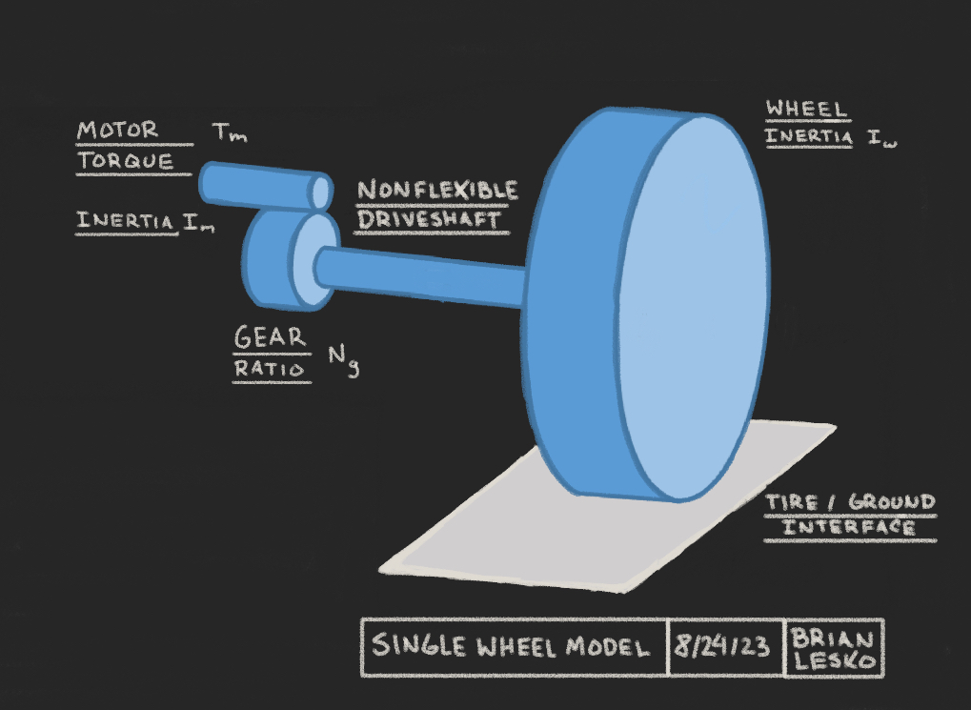

Figure . Single wheel model

In vehicle simulations, adopting a single tire model offers a streamlined approach to investigate tire-road interactions. The inclusion of a modified Pacejka's Magic Formula significantly augments the model's precision, providing an empirical depiction of the nonlinear relationship between tire slip and the forces it generates. While this formula is adept at representing both longitudinal and lateral force behaviors across varying slip conditions, this specific aspect is not addressed in this paper.

Newtons second law then yields the differential equations of motion (EOMs). These EOMs were derived from the wheel's free body diagram, presented in Figure 2.

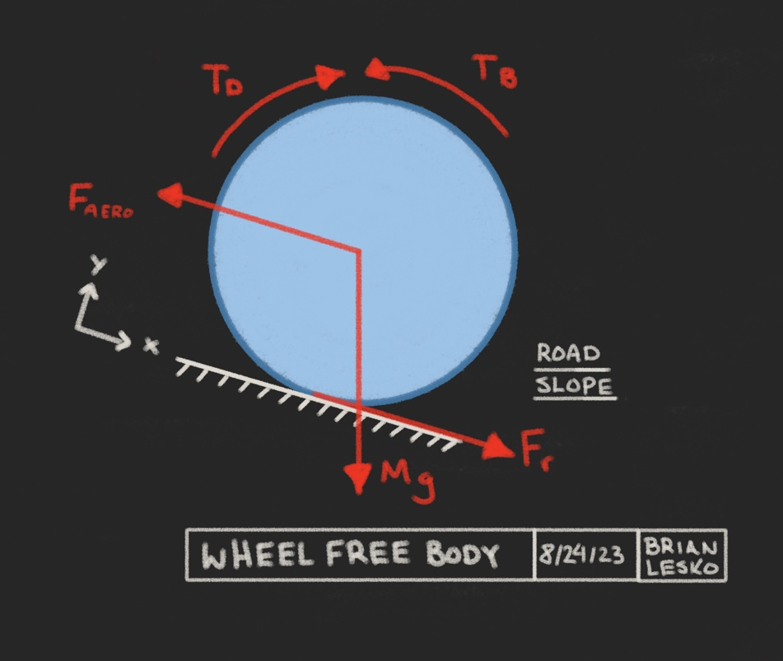

Figure . Wheel free body diagram

Using Newton’s second law, the equations of motion are solved by summing the forces in the x direction and summing the moments around the wheel’s axel. The two resulting equations of motion can be viewed below.

$$Ι_{w}\ddot{θ}=T_{D}-T_{B}-F_{r}R_{w}$$

$$M\ddot{x}=F_{r}+ Mg sin\left(α\right)- F_{aero}-F_{rolling}$$

The component equations are then chosen. The driveshaft torque is solved by considering the gear and an efficiency factor. The road force is modeled using previous work with the modified magic tire force equations, the aerodynamic and rolling forces with an existing empirical study originating from ECE 5553, and the slip as the positive fractional difference between the vehicle’s velocity and wheel edge velocity. Each component equation can be viewed below.

$$T_{D}=T_{m}N_{g}C_{efficiency}$$

$$F_{r}=dugoff(slip,α,μ)$$

$$F_{aero}= {\frac{ρC_{d}A_{f}}{2}(\dot{x}+V_{wind})}^{2}$$

$$F_{rolling}= C_{rr} M cos⁡(α)$$

$$slip=\frac{\dot{θ}R_{w}-\dot{x}}{max⁡(\dot{θR_{w},\dot{x}},0.00001)}$$

The variables index can be seen next in table 1.

|  |  |  |
| --- | --- | --- |
| Variable | Description | Units |
| $$N_{g}$$ | *gear ratio* | *None* |
| $$T_{m}$$ | *motor torque* | $$Nm$$ |
| $$T_{b}$$ | *brake Torque* | $$Nm$$ |
| $$I_{w}$$ | *wheel moment of inertia* | *Kg / $m^{2}$* |
| $$θ$$ | *wheel rotation* | $$rad$$ |
| $$\dot{θ}$$ | *wheel rotational speed* | *rad / $s$* |
| $$\ddot{θ}$$ | *wheel rotational acceleration* | *rad / $s^{2}$* |
| $$F_{r}$$ | *road force* | *N* |
| $$R_{w}$$ | *wheel radius* | *m* |
| $$M$$ | *vehicle mass* | *kg* |
| $$x$$ | *system position* | *m* |
| $$\dot{x}$$ | *system velocity* | *m/ $s$* |
| $$\ddot{x}$$ | *system acceleration* | *m/ $s^{2}$* |
| $$F_{aero}$$ | *wind force* | *N* |
| $$F_{rolling}$$ | *rolling resistance force* | *N* |
| $$C_{d}$$ | *drag coefficient* | *None* |
| $$C_{efficiency}$$ | *drivetrain efficiency coefficient* | *None* |
| $$C_{rr}$$ | *Rolling resistance coefficient* | *None* |
| $$C_{x}$$ | *Slip Stiffness* | *N per slip* |
| $$ρ$$ | *air density* | *kg / $m^{3}$* |
| $$V_{wind}$$ | *wind velocity* | *m/ $s^{2}$* |
| $$A_{f}$$ | *Vehicle frontal area* | $$m^{2}$$ |
| $$α$$ | *road slope* | *rad* |
| slip | *Fraction of wheel slip* | *None* |
| $$μ$$ | *Road surface coefficient of friction* | *None* |

Table . Equations of motion variable list

The nonlinear aspects contained in the component equations are the slip, aerodynamic drag, and road force components. These nonlinear equations necessitate solving the system using numerical methods.

Numerical methods are computationally expensive and run for long periods of time. The current popular method of implementation for numerical simulation in control systems is Simulink and is chosen to model the EOM’s. The model created directly to simulate the EOM’s can be seen in Appendix A.

# Chapter 3. Simulation Setting

Following the derivation of the equations of motion, simulation scenarios were chosen with the goal of collecting velocity-time responses. With a core interest in scenarios where the net wheel torque was held at a constant positive or negative value, both accelerating and braking responses could be recorded and indexed by the brake or motor torque respectively. Other possible inputs were held at constant values such as a road slope of zero and a road surface coefficient of friction of 0.7. At first, the sole usage of a near zero initial speed was considered for acceleration scenarios. Which resulted in the following simulations, animated after running, viewable in Figure 3 next.



Figure . Preliminary simulations

Each response is not plotted simultaneously, this shows the difference in timesteps automatically chosen during each simulation, reflecting the runtime. The lagging responses required smaller time steps while the leading responses took the least amount of timesteps.

After this initial round of simulation, it was hypothesized that the starting velocity of the vehicle would be important in later research processes, and so it was decided that both the starting velocity and the motor torque were to be varied during acceleration simulations. Similarly, the starting velocity and brake torque were chosen to vary during braking simulations. Each simulation scenario chosen can then be visualized in a 2d plane. Viewable next in Figure 4.

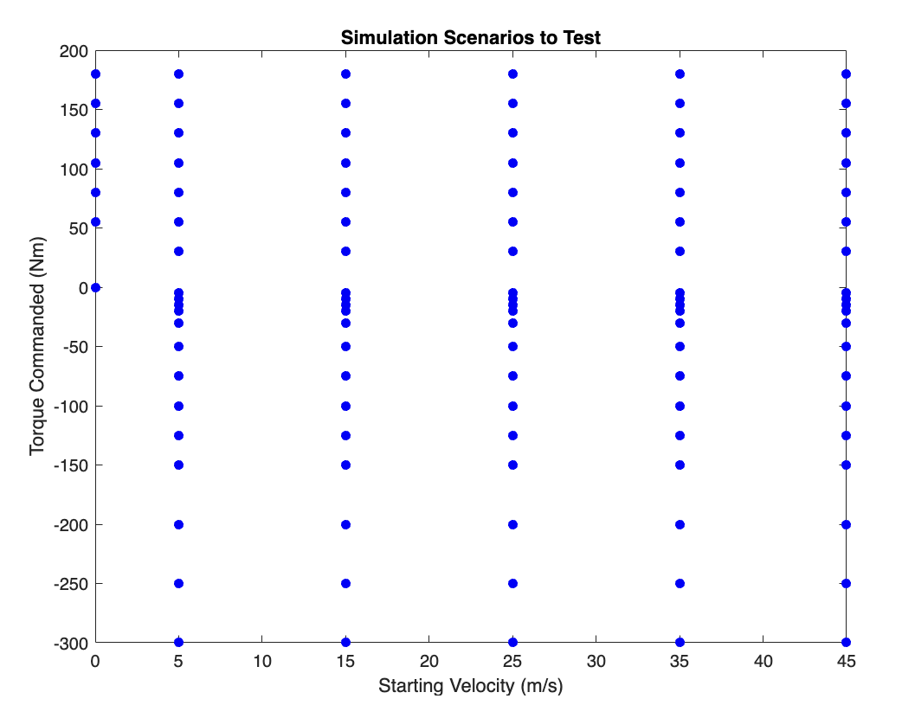

Figure . Simulation scenarios selected

Each blue datapoint represents a simulation to be run. Notice how there are many more simulations planned for the negative near zero motor torque region. These are moderate to low braking torque simulations, posited to become increasingly different closer to 0 torque.

This plane depicts the simulations planned concisely, defines a high standard of neatly organizing simulation parameters, and creates an environment that allows for low effort modification and repetition. These qualities are important to achieve in data-based studies.

# Chapter 4. Simulation results

The simulations were run one at a time, stepping through the planned torque and start velocity plane - each simulation result was saved as a data table. Table entries included the wheel slip, road friction, road slope, wheel speed, and more at each timestep, these are left for another time and the velocity response is recorded to be studied further. The velocity time graph results of the simulations were then visualized separately for the positive and negative torque commands, positive being the motor torque and negative being the braking torque. Combined scenarios were not run. The results can be seen in Figures 5 and 6 next.

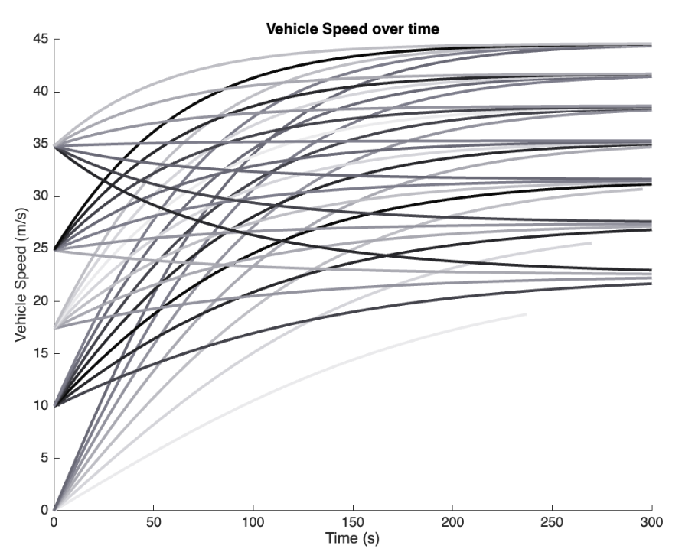

Figure . Acceleration simulation velocity time graph

At higher starting velocities, the velocity can be seen decreasing over time when the motor torque is not high enough to support the current velocity. These are decreasing systems with positive inputs.

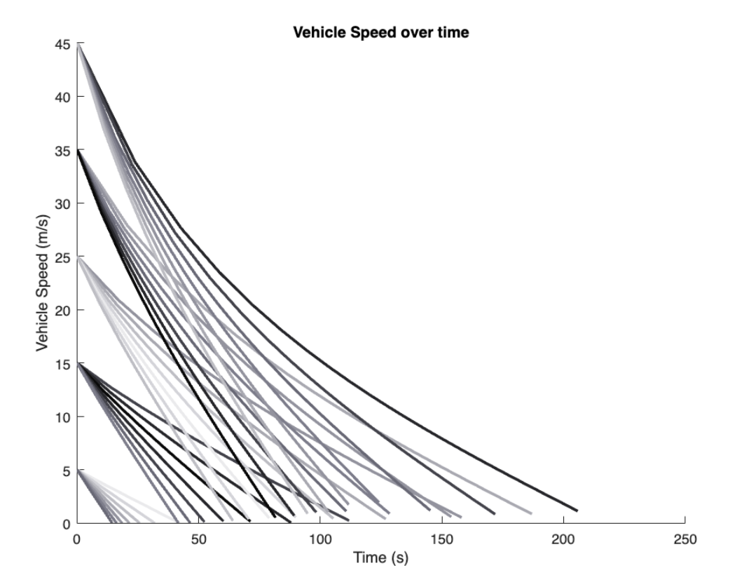

Figure . Braking simulation velocity time graphs

These simulations are decreasing as a response to a negative input, and are therefor increasing systems.

Note that these simulations have room for tuning with the various coefficients and parameters used. These can be modified to replicate the responses of many vehicle types, but for these simulations, the base parameters were chosen to model a typical sedan, and after some slight tuning of the rolling resistance coefficient, the above results were selected to continue with. It’s also worth noting that the size of data here is immense and needed to be sampled evenly in order to handle the data effectively.

# Chapter 5. Data fitting

In vehicle system control, systems are often linearized for controller tuning. Likewise, the velocity time curves can be approximated with the same methods. This has the benefit of approximating the results well with a much lower data size and recall speed. Most commonly, the first order system is used to approximate the log like shape exhibited by the vehicles accelerations. The first order system’s general equation in the Laplace domain and time domain are viewable below.

$$Y=K/(Ts+1)$$

$$Y=K-K e^{-t/T}$$

|  |  |  |
| --- | --- | --- |
| Variable | Description | Units |
| Y | *System output* | n/a |
| s | Laplace domain variable | n/a |
| t | time | seconds |
| K | System amplitude | n/a |
| T | System time delay | seconds |

Table . Laplace Transform

Again, the primary benefit is simplifying the data that have been collected which will make it easier to work with because of its decreased size and compute time. Secondarily, the method used is common in control system for tuning and modeling purposes for the same reasons. However, there is one improvement yet to be made. This first order system must be formatted as input over output. The output will be the velocity response, and the input is the torque used – either motor or brake torque denoted by positive or negative values respectively. This necessitates a response transform, dividing the velocity response by the torque used. This transform for the initial acceleration responses can be seen, animated, below in Figure 9.



Figure . Transfer function estimation

The resulting curves highly resemble the first-order systems characterizable by two distinct parameters. These estimations were made and the accuracy of each was evaluated visually. (Add MSE Surface study). Each estimation was made using the first order approximation using time delay as the 63% rise time and the amplitude as the maximum or minimum value for acceleration or braking respectively. Each estimation can be seen in the Flipbook animation below in Figure 10.



Figure . First order system approximations

Note that there are both increasing and decreasing systems in these models. Also, there are simulations that do not reach a steady state output; these simulations seem to have higher error in their linear estimations, but how does that relate to the operating envelope and the estimation methods?

# Chapter 6. Fit Evaluation

The next step is characterizing the error of each linear model in comparison to its original data. Previously, the error is visible in Figure 8 as the difference between the two curves. However, any trends in the error are not easily recognizable. Thus, quantifying the error is necessary, using a metric such as root mean square error. Using both the operating envelope from Figure 4 and RMSE values, a three-dimensional plot can be formed, and interpolation can be used to create a surface. The results can be seen in Figure 9 below.



Figure . Root mean squared error of the model estimations.

# Chapter 7. Model Estimation

The previous model fits result in discrete linear system estimations. These systems are great for estimating the simulated responses at saved inputs. However, the results are not directly usable for non-simulated inputs without interpolation methods.

With interpolation, simulation results can be estimated without undergoing the long runtime. This can aid in control methods, system tuning, and system analysis.

Using interpolation, the parameter estimations for K and T were then visualized using a surface to better understand how the system dynamics change with varying torque and velocity. The surfaces can be viewed next in figures 10 and 11.



Figure . Amplitude, K estimation



Figure . Time delay, T estimation

The limitations here are estimations around the asymptotes in both parameter graphs. Overall, the valid interpolation bounds are limited to being interior to the simulated points. See Figure 12 below.

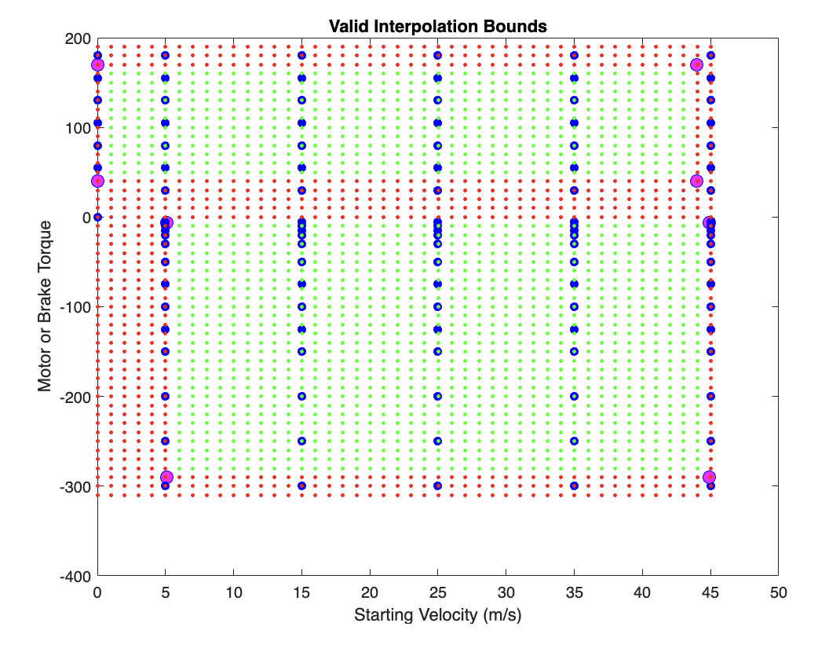

Figure . Interpolation bounds

This figure recaps the original simulation results as blue data points where the green data points are valid interpolations while the red must be handled with extrapolation methods yet to be implemented. Lastly, the pink data points are hypothesized locations for PID controllers

# Chapter 6. Conclusions and future work: WIP

Overall, this paper reviews the study of longitudinal vehicle dynamics through simulation methods while diving into parameter and model estimation through the lens of data visualization.

Continuing avenues of the topics discussed in this paper include the following. One, tuning controllers for vehicles navigating through the parameter space. Two, selecting the correct simulation gridding to study interpolation accuracy for plant parameters. Three, tuning plant estimations to more closely match a real world vehicle.

# Bibliography

Turabian, Kate L., A Manual for Writers of Term Papers, Theses, and Dissertations. 5th ed. Chicago: University of Chicago Press, 1987.

While a list of references may appear at the end of each chapter, the final submitted document must have a unified bibliography that covers the entire document.

A consistent style must be used for the references in the bibliography.

**DELETE THIS INSTRUCTIONAL BOX BEFORE PRINTING.**

# Appendix A. Simulink Model

# Appendix B. Code Repositories

18

Figure Sample Landscaped Page